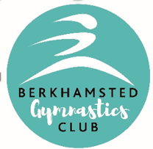
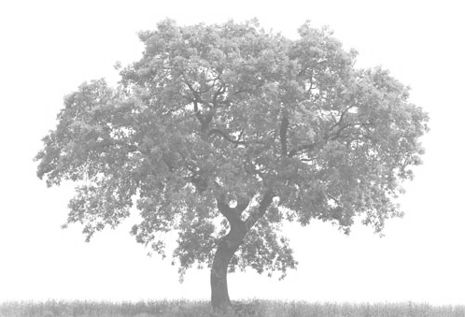




BERKHAMSTED GYMNASTICS CLUB
Progressions Tree
NOVICE
INTERMEDIATE
ADVANCED
TEENS
Age 13 plus
Progression within Gymnastics
allows children to explore, improve and refine movements with skilful control and development. Takes time, commitment, hard work, and repetition. Making sure from the first steps that gymnasts understand the basic skills are so important to move up the progression tree.
PRE-SCHOOL
Age 2-5yrs

