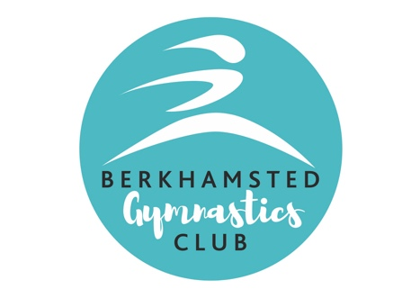

Specially designed gymnastics apparatus for the Under 5’s
TERM TIME COURSES
Monday :
Me and You (1.5 - 3 years) 10am–10.45am
Mini Munchkins (3 - 4 years) 11am–11.45am
Mini Munchkins:(3-4 years) 1pm–1.45pm
Mini Munchkins:(3-4 years) 2pm–2.45pm

Wednesday
ME AND YOU (1.5-3 YEARS)10AM-10.45AM
MINI MUNCKINS: (3-4 YEARS)1PM-1.45PM

Friday :
Me and You (1.5 -3 years) 10am–10.45am
Mini Munchkins:(3-4 years) 11am–11.45am
Mini Munchkins:(3-4 years) 12pm–12.45pm
Mini Munchkins:(3 -4 years) 1pm-1.45pm
Call Today 07484 115 592 for a Taster Session
– Taster session £7.15

DROP IN SESSIONS
Monday Let’s Play: 12pm –1pm
Wednesday LETS PLAY: 11AM - 1PM
DROP IN SESSIONS 30MINS: £3.50
ONE HOUR £5.00

www.berkhamstedgymnastics.co.uk
Find us on Facebook – Berkhamsted GC – toddlers gymnastics Site Address: Gossoms End Scout Hut, Queens Road, Berkhamsted, HP4 3HU

Registered Charity: 267968

